IB English A: Language and Literature HL Y1

Written by James Stewart

Illustrated by K. Roméy

Summer Assignment

Intertextuality

#1
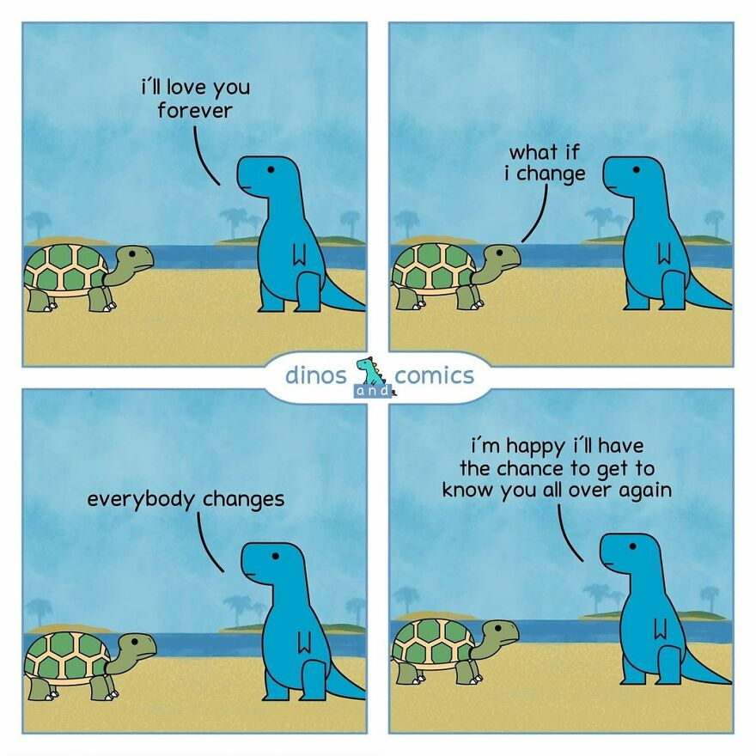
Image source: dinosandcomics

#2
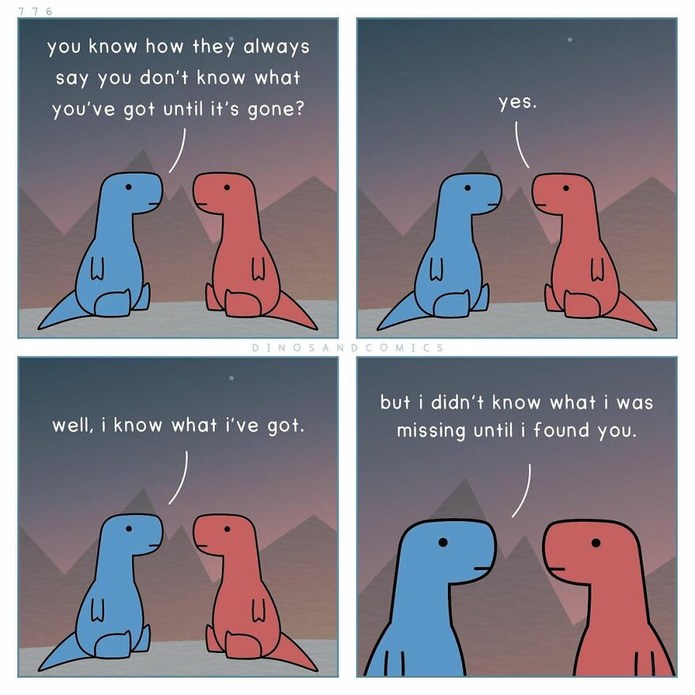
Image source: dinosandcomics

#3
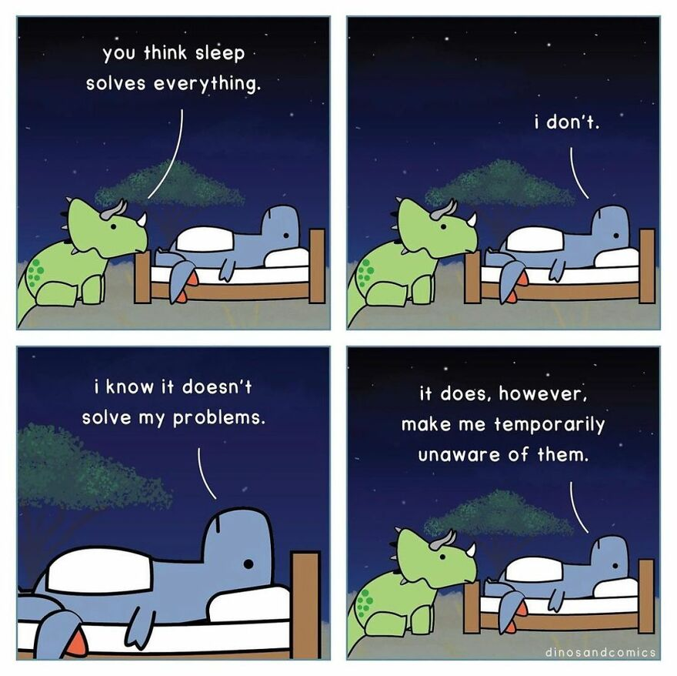
Image source: dinosandcomics

#4
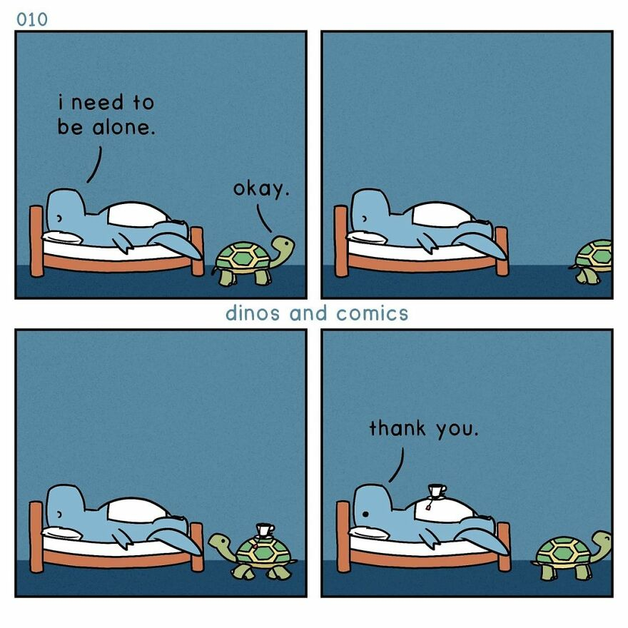
Image source: dinosandcomics

#5
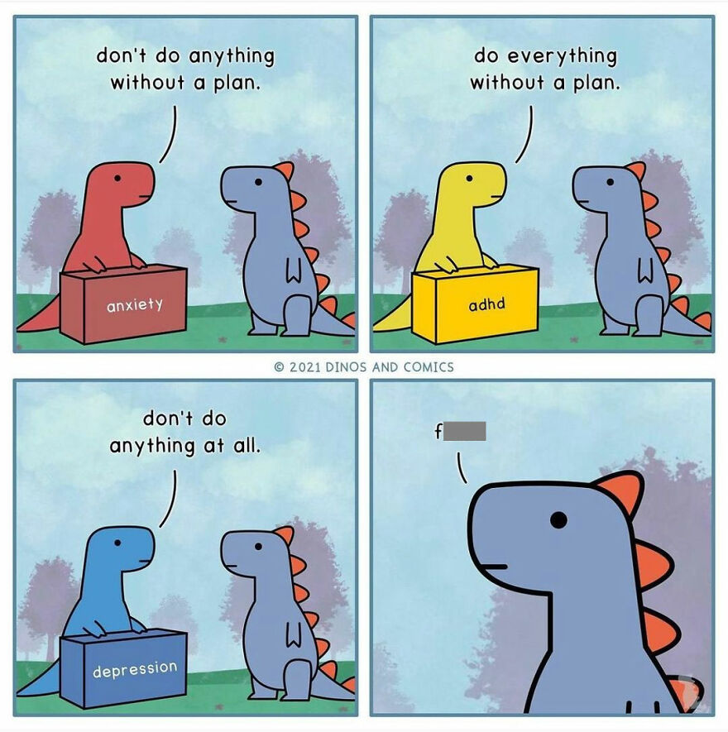
Image source: dinosandcomics

#6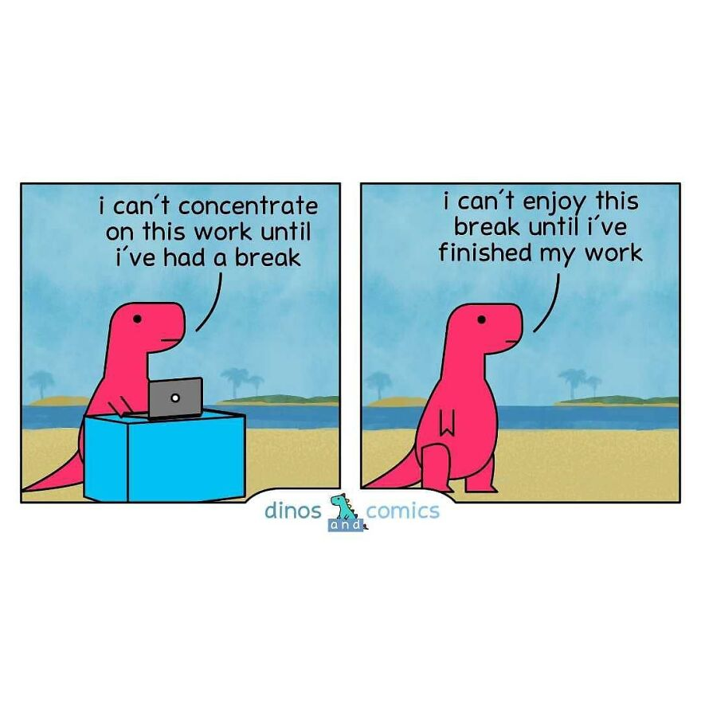Image source: dinosandcomics

#7
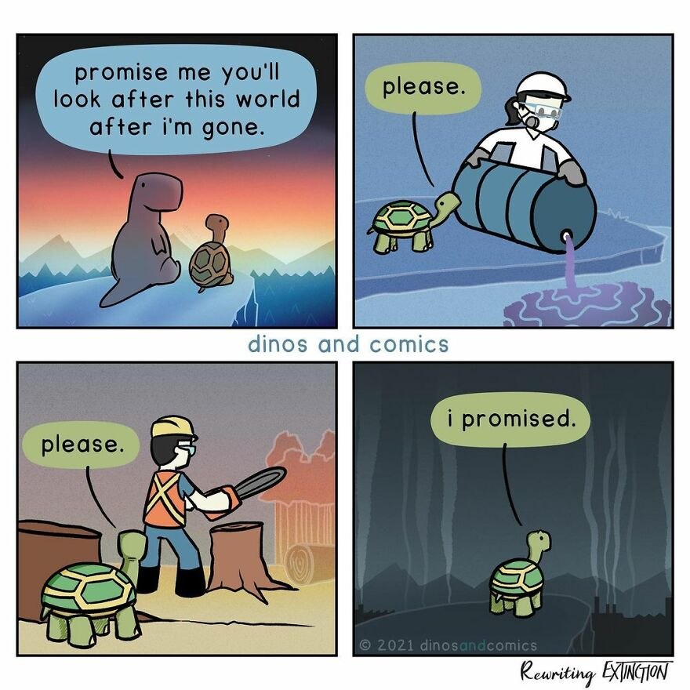
Image source: dinosandcomics

#8
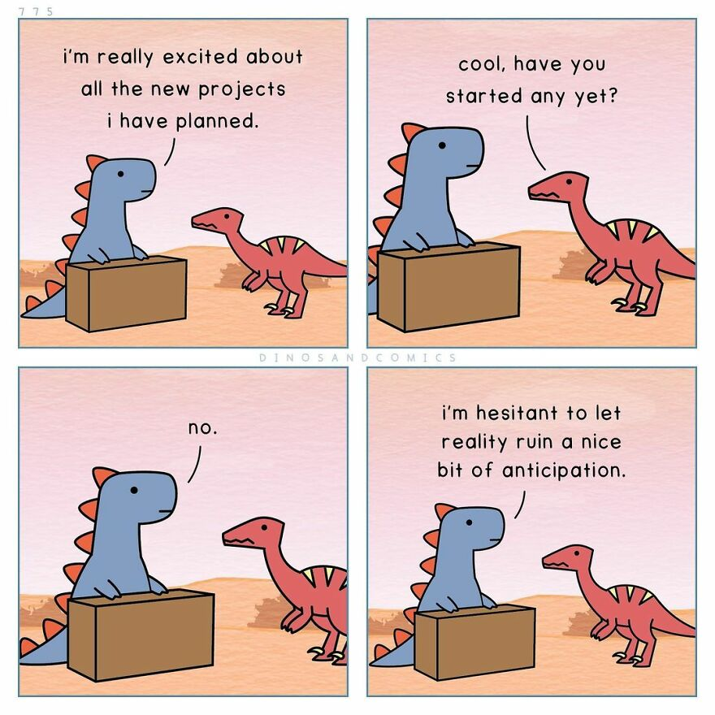
Image source: dinosandcomics

#9
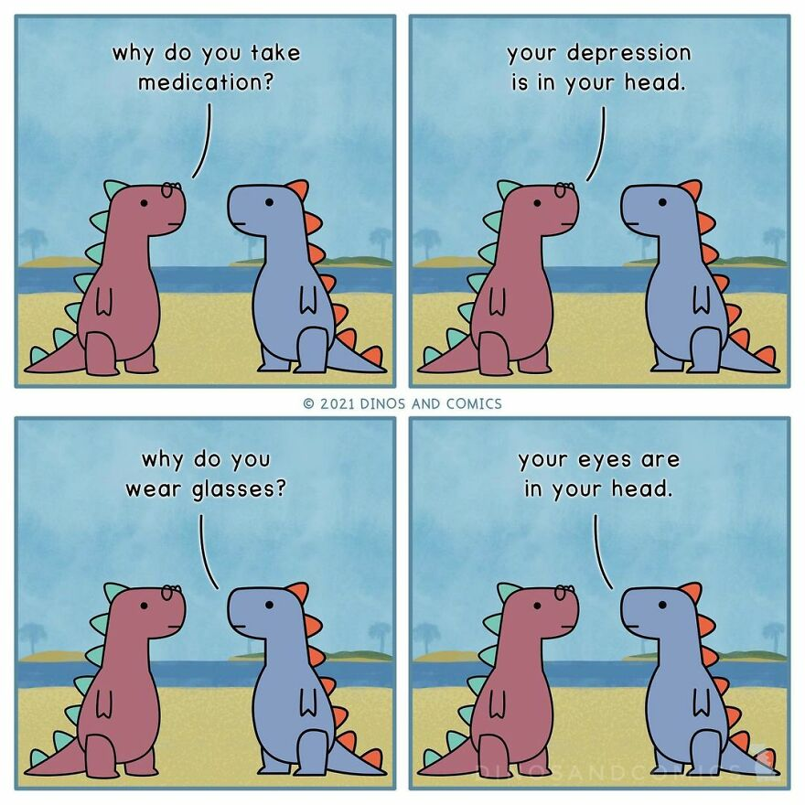
Image source: dinosandcomics

#10
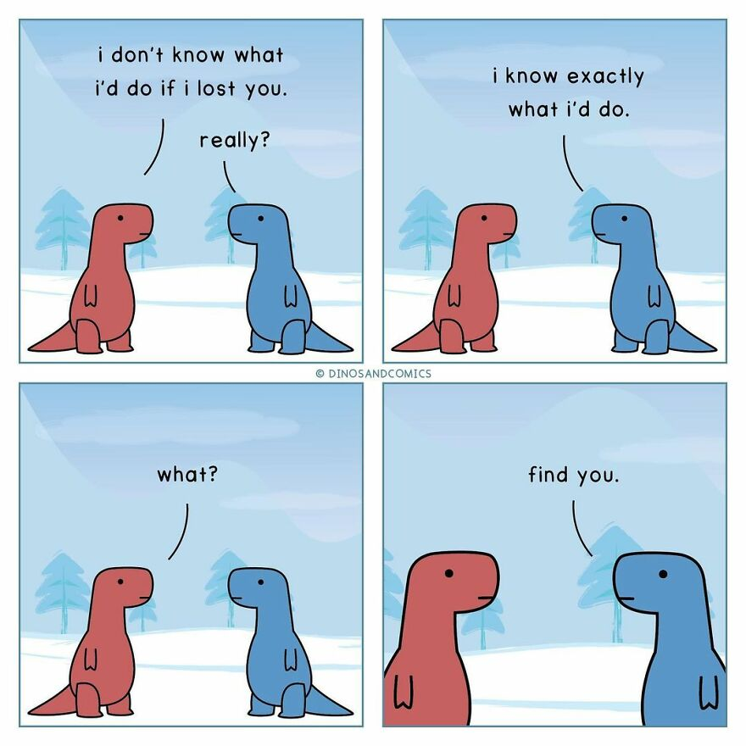
Image source: dinosandcomics

#11
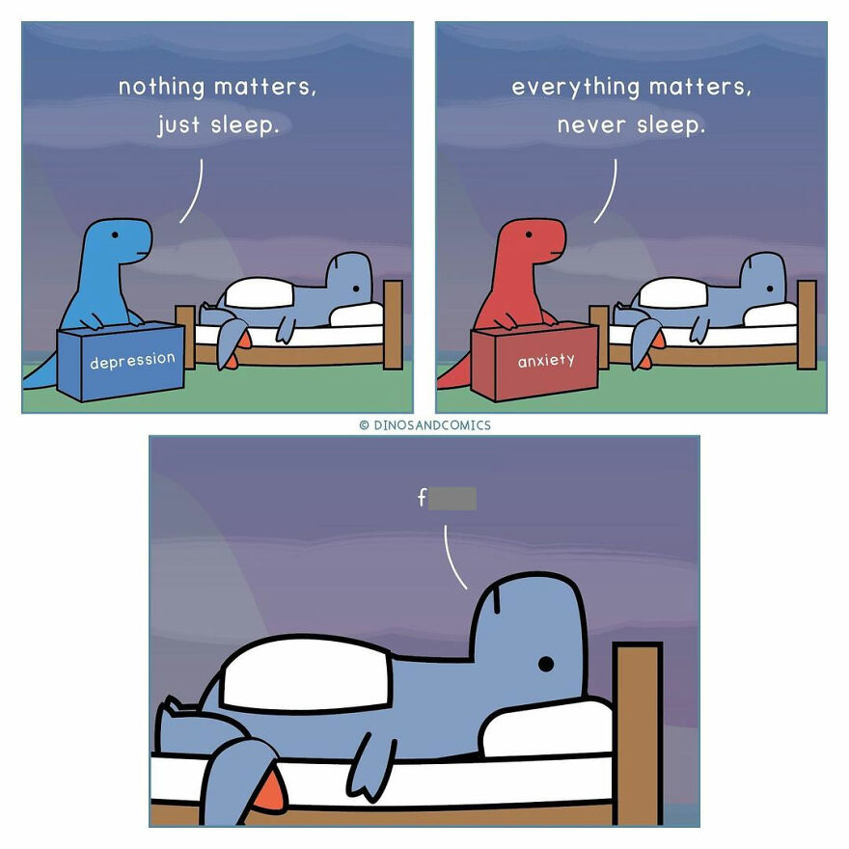
Image source: dinosandcomics

#12
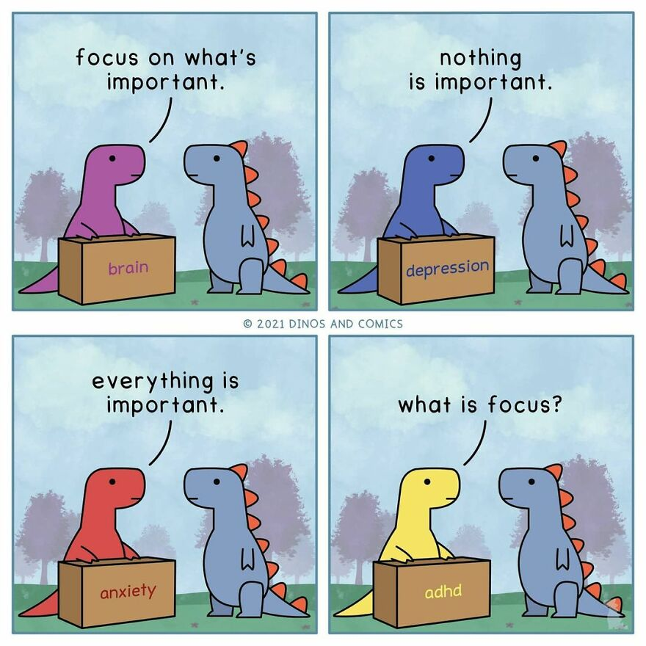
Image source: dinosandcomics

#13
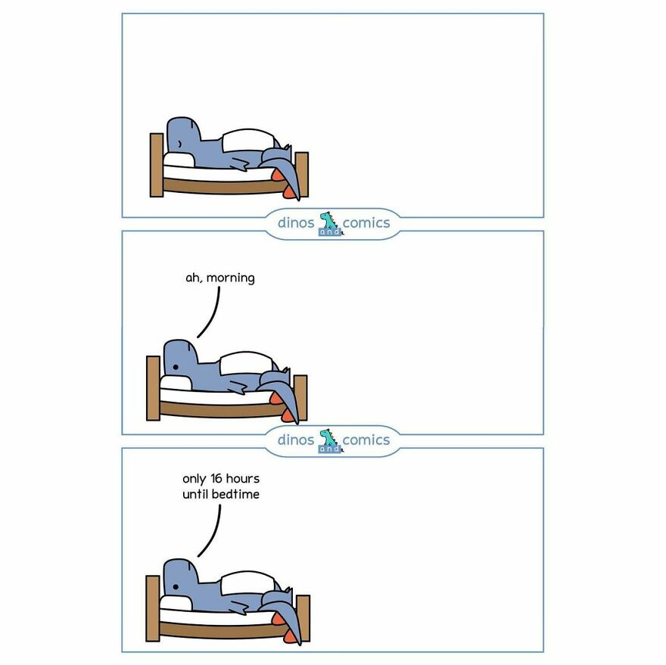
Image source: dinosandcomics

#14
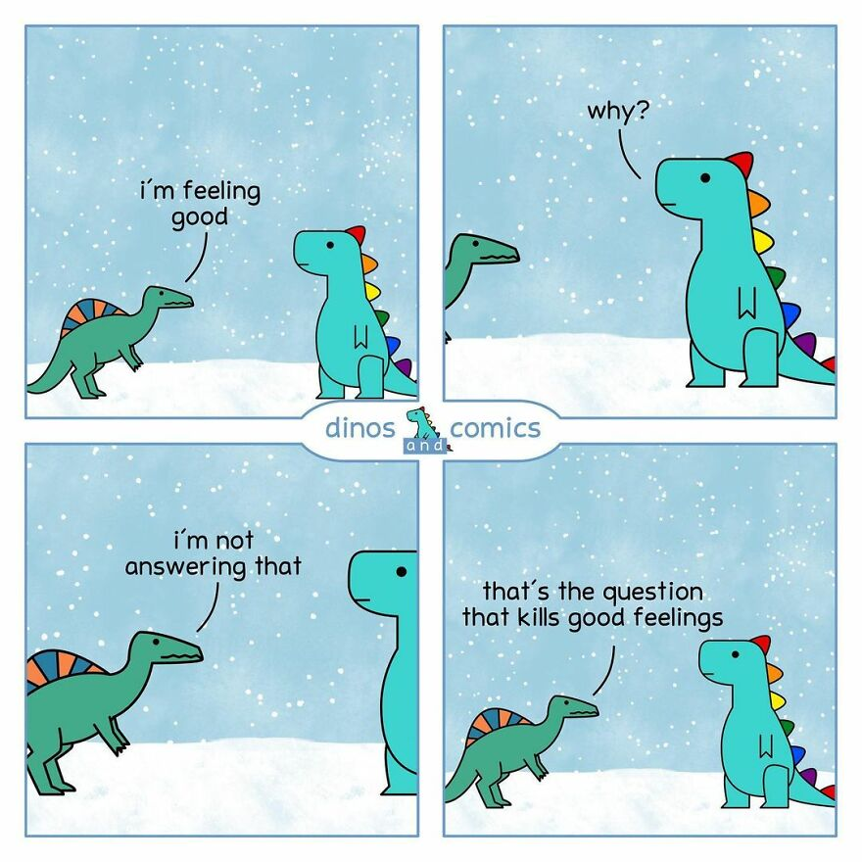
Image source: dinosandcomics

#15
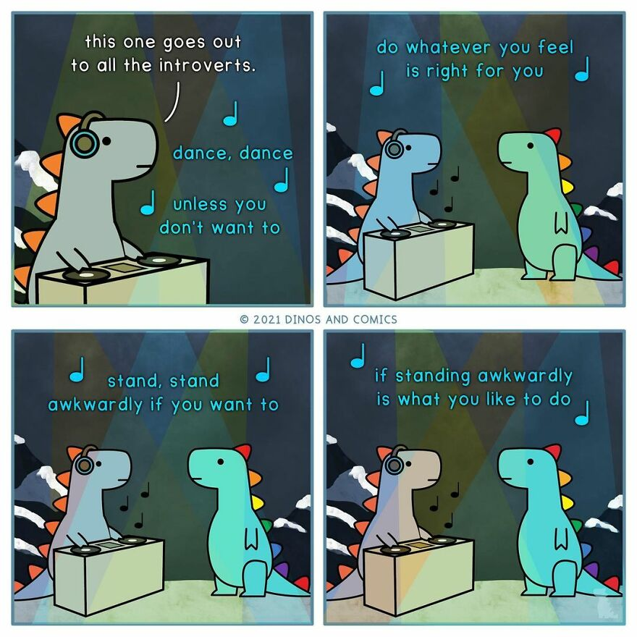
Image source: dinosandcomics

#16
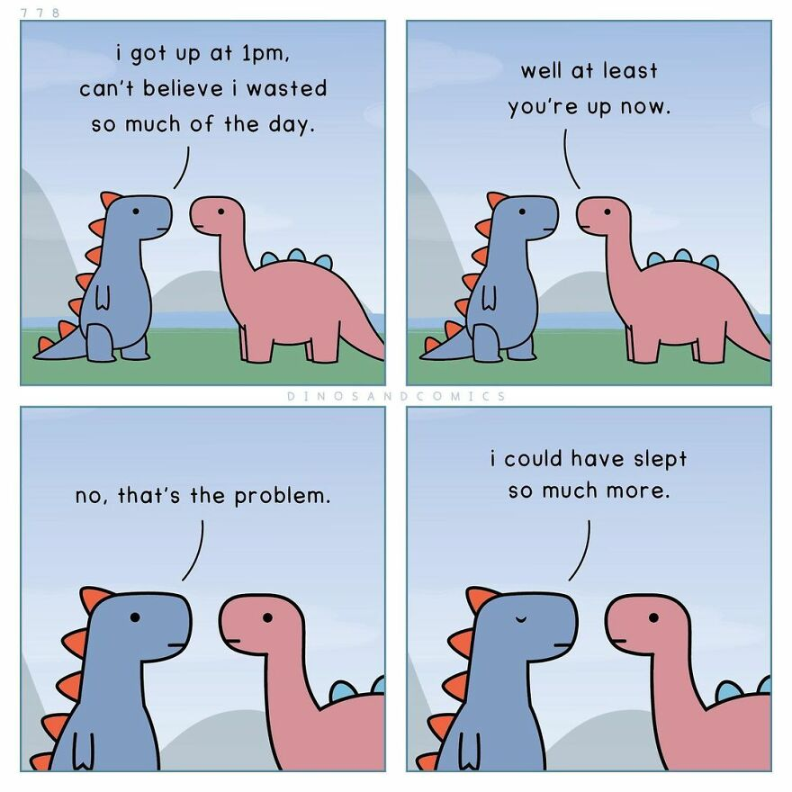
Image source: dinosandcomics

#17
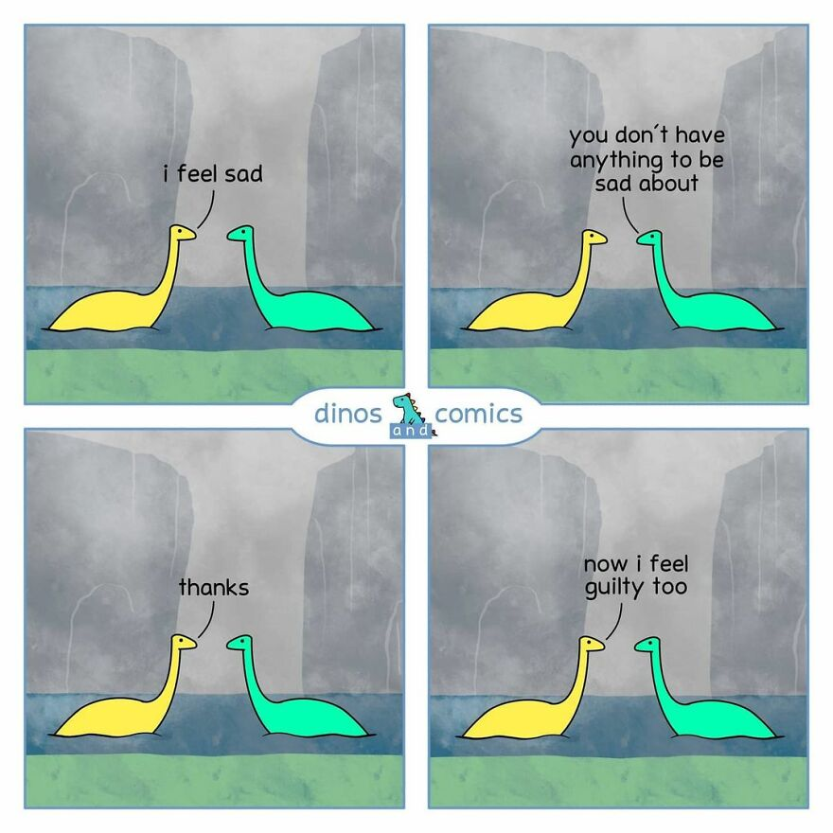
Image source: dinosandcomics

#18
Image source: dinosandcomics

#19
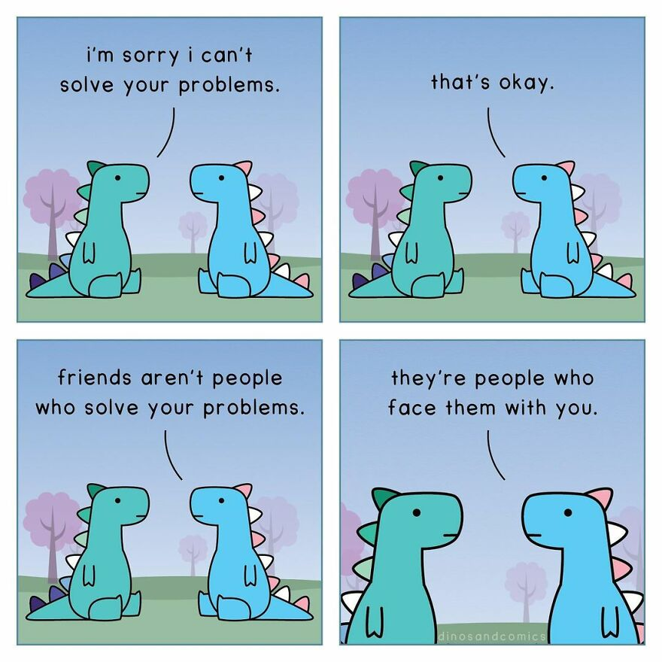
Image source: dinosandcomics

#20
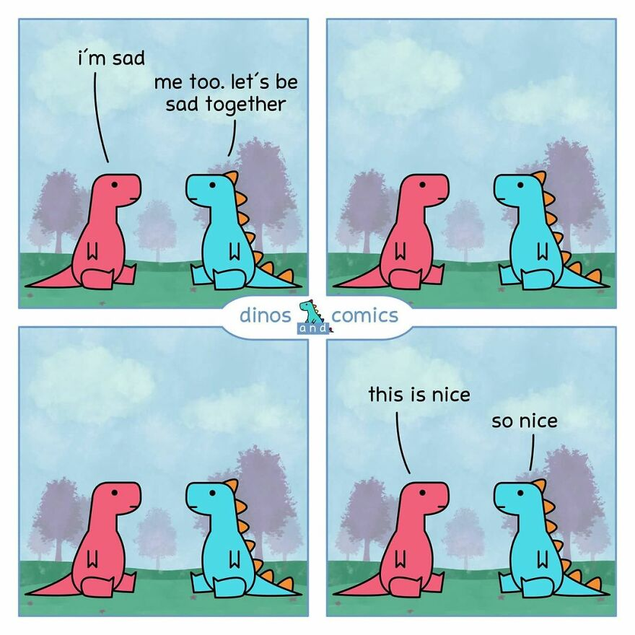
Image source: dinosandcomics

